**16.11.2013:**

**ISSUE: Hide / Remove URL from pop-up window**

The pic below shows the steps to **hide URL** on **MOZILLA-FIREFOX** on pop-up window:

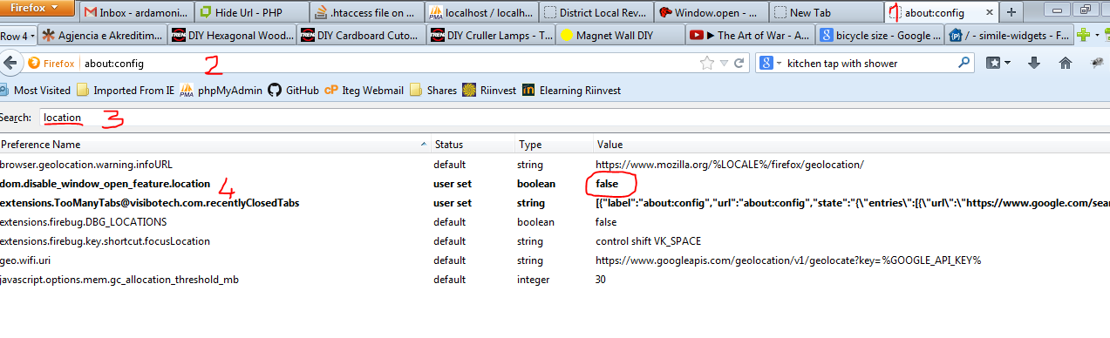

This is achieved in 5 steps:

1. Start the New tab
2. Type **about:config** in the address bar. Approve the security warning
3. In search type **location**
4. If **dom.disable_window_open_feature.location** is set to **true** (by default) double click on it to set it to **false** (this will allow the code in JS to be doing what is supposed to do hide location)

var popupWindow = window.open (pageURL, title, 'toolbar=no, **location=no**, directories=no, status=no, menubar=no, scrollbars=no, resizable=no, copyhistory=no, width='+w+', height='+h+', top='+top+', left='+left);

1. Restart Mozilla-Firefox